**Cloud-Based Smart Health Care System**

**Khushi**

*Department of Computer Science,*

*KIET Group of Institutions, Delhi-NCR, Ghaziabad, Uttar Pradesh, India*

[khushi.2024cs1208@kiet.edu](mailto:khushi.2024cs1208@kiet.edu)

**Chhayank Tyagi**

*Department of Computer Science,*

*KIET Group of Institutions, Delhi-NCR, Ghaziabad, Uttar Pradesh, India*

[chhayank.2024cs1010@kiet.edu](mailto:chhayank.2024cs1010@kiet.edu)

**Hanu Agarwal**

*Department of Computer Science,*

*KIET Group of Institutions, Delhi-NCR, Ghaziabad, Uttar Pradesh, India*

[hanu.2024cs1020@kiet.edu](mailto:hanu.2024cs1020@kiet.edu)

**Harsh Khatter**

*Department of Computer Science,*

*KIET Group of Institutions, Delhi-NCR, Ghaziabad, Uttar Pradesh, India*

[harsh.khatter@kiet.edu](mailto:harsh.khatter@kiet.edu)

***Abstract-* The primary goal of this work is to meticulously preserve patients' reports, encompassing details like medical history. The essence of this paper lies in presenting a solution that facilitates the identification of suitable physicians based on user-provided symptoms and accompanying reports. Beyond this central objective, an exploration of additional components forms the basis for the proposed system, intending to offer a comprehensive solution that amalgamates various healthcare facilities. A pivotal aspect of this innovation is the integration of a feature for generic medicines, which aims to augment existing healthcare systems. By centralizing and streamlining the storage of patient data, the proposed system seeks to provide a unified and efficient healthcare solution. Furthermore, the ability to match symptoms with appropriate doctors enhances the user experience and ensures personalized care. The multifaceted approach of this paper underscores its ambition to serve as a holistic, one-stop solution for diverse healthcare needs. Through the incorporation of features such as generic medicine availability, the proposed system aspires to not only meet current healthcare demands but also contribute to the overall enhancement of healthcare delivery system.**

***Keywords: Cloud Computing, Health Care, Medical Care, IoT, Image Processing.***

1. **INTRODUCTION**

In today's healthcare, new technologies are causing big changes, and one of those changes is called "smart care." This project is all about using the latest technologies like artificial intelligence (AI), the Internet of Things (IoT), and data analytics to make a real difference in how we take care of patients, figure out what's wrong with them, and treat their health issues. These technologies work together to give us exciting chances to improve healthcare. For example, we can monitor patients in real-time, predict potential health problems before they become big issues, and create personalized treatment plans that fit each person's unique needs. With "smart care," healthcare groups want not only to make medical treatments more efficient and effective but also to make healthcare services available to more people.

In healthcare, there's a constant effort to find new and better ways to meet the changing needs of patients and healthcare providers. The "smart care" project is part of this effort, bringing in AI, IoT, and data analytics to use the latest technology for the good of healthcare. These technologies help doctors and healthcare workers understand more about patients' health, make decisions faster, and create a healthcare system that really focuses on what each patient needs. As "smart care" progresses, it shows how committed healthcare groups are to using innovation and technology to make healthcare better, moving into a new time of improved patient care and medical success.

Current online healthcare faces several challenges, including concerns related to data privacy and security, as the vast amount of sensitive patient information transmitted over digital platforms raises the risk of unauthorized access or cyberattacks. Additionally, the lack of standardized regulations across online healthcare services can result in varying quality and reliability, posing potential risks to patient safety. Access disparities, particularly among marginalized or technologically underserved populations, exacerbate existing healthcare inequalities. Furthermore, issues related to the accuracy of online diagnoses and the potential for misinterpretation of medical information present challenges in ensuring the delivery of trustworthy and effective virtual healthcare services. Addressing these issues is crucial to establishing a robust and inclusive online healthcare ecosystem.

The Smart Care project comprises four main modules that describe the basic functionality of the website. The first module is the Home page, which serves as the landing page and includes sections for vision, mission, terms of service, policies, and a contact us section. The second module is the Service page, presenting all the services offered by the website. These services encompass Blood Bank, E-pharmacy, Path Labs, Gym, Yoga, and Homeopathy. Additionally, the Service page provides essential information on contacting us, privacy policy, and terms of services. The third module is the Doctor module, which includes options for doctor login or new registration. Upon successful login, the dashboard becomes visible, containing basic information such as name, specialization, education, experience, location, contact number, and email. Doctors can access their patient list, which includes patient names, ages, medical history, and contact numbers. The module also allows doctors to add patients by filling in their details. The website distinguishes itself by offering a unique feature: a list of other doctors with the same specialization, including their contact numbers and locations. Smart Care also provides features for doctors to view the list of all registered hospitals where a particular doctor is working. The fourth and final module is the Patient module, which includes a patient dashboard displaying name, age, medical history, and contact number. The Patient module also features a list of doctors the patient has visited or is currently consulting. Patients are required to add their medical history, detailing previous treatments by other doctors, along with the problems and treatments. The module further includes a documents section where patients can upload all necessary documents used by the doctors.

1. **LITERATURE SURVEY**

|  |  |  |  |  |
| --- | --- | --- | --- | --- |
| **Author[Year]** | **Description** | **Advantage** | **Implementation** | **Drawback** |
| Keith P. Waters et al.[2013] | Impact of Kenya Health Workforce Information System (KHWIS) on policy and management | Improved health worker regulation, management, and policy; increased relicensing | Successful utilization of KHWIS data in policymaking and regulation | Limited references to KHWIS in government records |
| Jonathan H Williams et al.[2004] | Aflatoxicosis in developing countries: toxicology, exposure, health consequences, interventions | Aflatoxin exposure impact on nutrition and immunity; potential for interventions | Focus on animal studies; limited information on human health consequences | Lack of comprehensive data on human health impacts of aflatoxin exposure |
| Xi, Li; Cheng, Kar[2017] | The primary health-care system in China | Challenges in structural characteristics, incentives, and policies; importance of HRM | Opportunities for integrated primary health care system in China | Inadequate education and qualifications of health care workforce |
| Stefane M Kabene et al.[2006] | Importance of HRM in health care: a global context | HRM critical for high-quality health care; need for policy development | Refocus on HRM needed; more research for policy development | Challenges in workforce education and turnover |
| Michael F. Leahy et al.[2017] | Improved outcomes and reduced costs with a health-system–wide PBM program | Reduction in blood product utilization; cost savings; improved patient outcomes | Successful implementation of jurisdiction-wide PBM program | Specific drawbacks not mentioned in the provided excerpt |
| John Ruedy et al.[2014] | The challenge of providing global health education: insights from key informants | Challenges in global health education; importance of partnerships | Importance of partnerships in addressing global health education challenges | Limited insights from the provided excerpt |
| Olawale Salami et al.[2018] | Impact of mobile health on maternal health care service delivery in resource-limited settings | Improved maternal health care services; enhanced data collection | Successful implementation of mobile health in resource-limited settings | Potential challenges in technology access and infrastructure |
| Samuel Danso et al.[2016] | Application of GIS in optimizing the location of health facilities | GIS benefits in health facility location optimization | Successful application of GIS in health facility planning | Possible challenges in data accuracy and system implementation |
| Wendy J Graham et al.[2016] | Universal health coverage: a call for action | Importance of universal health coverage; key action areas | Call for global action for achieving universal health coverage | Limited details on specific action plans |
| Martin McKee et al.[2014] | Global health in foreign policy: from sovereignty to solidarity | Shift from sovereignty to solidarity in global health; importance of foreign policy | Importance of solidarity in addressing global health challenges | Limited information on specific policy recommendations |

The literature survey presents a nuanced understanding of diverse health-related dimensions, spanning information systems, workforce management, and global health policies. The Kenya Health Workforce Information System (KHWIS) demonstrates improved regulation and policymaking, yet its limited incorporation in government records raises questions about widespread adoption. Aflatoxicosis research reveals the need for a more comprehensive exploration of human health consequences, shifting from the predominantly animal-focused studies. China's primary health-care system faces challenges in structural characteristics and human resource management, suggesting the potential for integrated solutions, but issues in workforce education and turnover persist.

Human Resource Management (HRM) emerges as crucial for global health care, but a call for refocus and increased research to guide policy development is apparent. Health-system-wide programs, like

Patient Blood Management (PBM), exhibit positive outcomes, yet specific drawbacks remain unaddressed. Global health education confronts challenges, emphasizing the significance of partnerships, while mobile health applications demonstrate promise in resource-limited settings, though technology access challenges linger.

Geographic Information Systems (GIS) offer benefits in optimizing health facility locations, acknowledging potential challenges in data accuracy and system implementation. The call for universal health coverage underscores global action, yet specifics on action plans are limited. The shift from sovereignty to solidarity in global health, discussed in foreign policy, emphasizes collaborative efforts, yet concrete policy recommendations are less explicit. In summary, the literature highlights both strengths and gaps in existing health care paradigms, calling for further research to address identified challenges and enhance global health systems inclusivity and effectiveness.

1. Top of Form

*A.Gap Observed*

Despite the advancements in medical technology and healthcare infrastructure, several gaps persist in the current system. One notable limitation lies in the storage and accessibility of patient information. Traditional systems often struggle to maintain a seamless repository of reports and records, leading to potential delays and inefficiencies in patient care. Moreover, the lack of a unified platform for collating and organizing diverse patient data contributes to a fragmented healthcare experience.

Additionally, the process of identifying suitable doctors for specific conditions remains a challenge. Patients often face hurdles in navigating the complex healthcare landscape to find specialists relevant to their symptoms. This inefficiency can result in delayed diagnosis and treatment, impacting overall health outcomes. The proposed system aims to revolutionize healthcare management by introducing a comprehensive approach to patient data storage and doctor selection.

One of the distinctive features of the proposed solution is its ability to match patients with suitable doctors based on provided symptoms. This innovative algorithm considers a multitude of factors, including the severity of symptoms, past medical history, and the expertise of healthcare providers. This approach minimizes the time and effort patients traditionally invest in finding the right specialist, fostering a more efficient and targeted healthcare delivery.

Beyond these core functionalities, the proposed system seeks to integrate various healthcare facilities into a cohesive platform. This one-stop solution aims to eliminate the need for patients to navigate disparate systems for different aspects of their healthcare e.g yoga , gym etc. The emphasis on a unified approach contributes to a seamless and interconnected healthcare experience.

Secondly, the innovative doctor selection algorithm represents a paradigm shift in how patients connect with healthcare providers. By automating and optimizing this process, the proposed system minimizes delays in diagnosis and treatment, ultimately improving health outcomes.

The inclusion of a generic medicine feature adds another layer of accessibility to the proposed system. By empowering patients with information on cost-effective alternatives, the system promotes financial inclusivity in healthcare.

While the proposed solution holds great promise, it is crucial to acknowledge potential challenges and consider mitigating strategies. One primary concern is data security and privacy. As the system centralizes vast amounts of sensitive patient information, robust security measures must be in place to safeguard against unauthorized access and breaches.

By integrating various healthcare facilities and incorporating a feature for generic medicines, the system strives to provide a holistic, one-stop solution for patients. While challenges exist, the potential benefits in terms of improved patient care, streamlined healthcare processes, and enhanced accessibility make this proposed solution a compelling avenue for further exploration and implementation in the evolving landscape of healthcare.

1. **Proposed System**

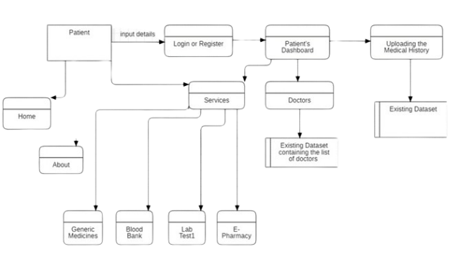

**Figure 2: Showing the patient’s data flow diagram level 1**

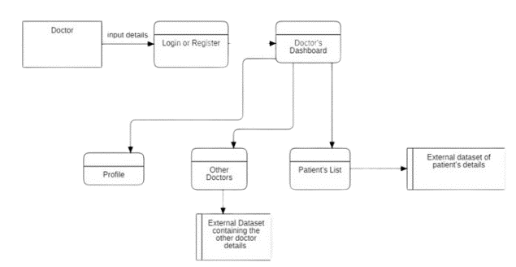

**Figure 3: Showing the Doctor’s dataflow diagram level 1**

1. ***Service Page***

* This is most important modules including many government services and generic services.
* Blood Bank is very necessary now days and this module include access links of government blood bank websites and listing necessary details regarding them.
* E pharmacy is pharmacy where we can buy medicines online and delivered at our doorstep at lowest price and with assured company.
* Path Labs is nearest path labs your location with price tags of many important medicals test and report at your doorstep.

1. ***Doctor***

This is the main module including many features:-

* Profile page include doctor experience and history of previous hospitals and many more.
* Patient record includes all the patients of doctor with medical history all reports , medicines and diseases .
* Doctors includes other doctors that are registered and every doctor can see other doctor profile for their patients and for their knowledge.

1. ***Patient***

This module is for patients :-

* Profile page include patients profile of previous doctor visits and medical reports .
* All doctors where visit for chech up and prescription given by doctor.
* Patient can view all their past documents in digital format.

IV. TECHNOLOGY

1. ***Hardware***

Even though this architecture is hardware- software integrated web architecture, we will not be designing any specific hardware interfaces to run the system. Our system is a web-based system, so we will be launching it in several computers online. Smart care projects may integrate with EHR systems to provide healthcare professionals with access to patient data. These systems can be connected to the web-based platform via APIs.

1. ***Software***

The Smart Care WebApp will depend on several open-source software components, including Html, CSS, JavaScript, API’s ,Spring MVC, Spring Security, Spring JDBC and Spring Boot. These components will be integrated into the web application to provide the necessary functionality and user interface. It is important to note that the operating environment described above is subject to change based on the needs of the project and the evolving requirements of the web application. It is recommended that the development team regularly review and update the operating environment to ensure that the software remains compatible with the latest technologies and platforms.

**V. IMPLEMENTATION**

**Detailed Description**

**Difficulty For Patients In Changing Their Doctor**-

* As their are lot of cases in which patients wish to change their doctors due to any reason whether the treatment is not suiting to his/her health, distance apart and many more.
* So in this case patients are unable to tell all their past history treatment clearly.
* This system is used to store each and every document of the particular patient.

**e- pharmacy –**

* E-Pharmacy can be a built in feature of this project
* By using online pharmacy the user can order the medicine anytime and anywhere.

**Path Labs –**

It encorporate the pathology labs, it will save a lot of time and allows the user to access all the options on a single website rather than searching each website individually.

**Doctor’ Dashboard –**

Doctor’s Dashboard allows doctor’s to access the appointed patient’s only. Doctor can see their past records also such as medical records, test results and past prescriptions (from other doctor). As doctor has to provide the electronic prescriptions, which reduces the risk of errors and making it easier for patients to refill their prescriptions. It also consists of many other options such as other doctors where the list of registered doctors are made visible.

* 1. *END USERS*

**Patients –**

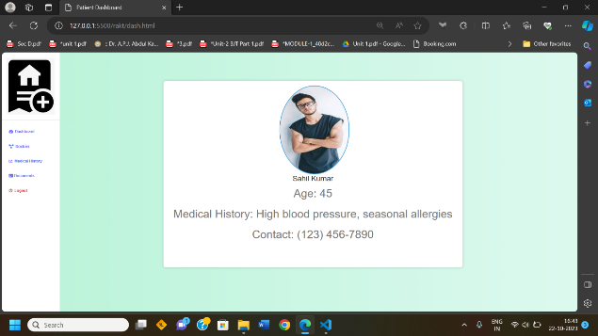

* Can save their documents
* Check for doctor according to their needs
* Compare medicine price

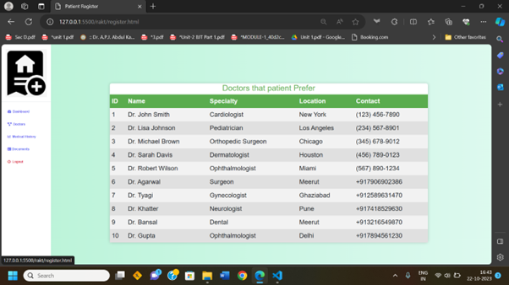

**Doctors-**

* Can save their patients history
* Take Help prescription of other doctors

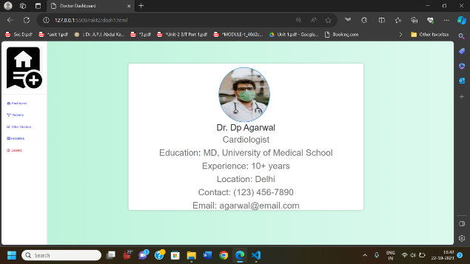

* 1. *ADVANTAGES*
* Access **-**the access of our website is not restricted to registered users only. Someone who is not registered can also visit the website
* User Registration and login **-** A user, must be able to register their credentials. one should provide their basic information eg. Name, address, email, phone number to create the profile.
* Electronic Health Records **-** This is a feature to digitalize the patient’s medical records , It’ll contain the patient's medical history, diagnoses, medications, treatment plans, immunization dates, and laboratory test results.
* Telemedicine **-** This feature allows the patient to buy the medicine online form the registered government websites. This feature helps the user to buy the medicines in low prices as compared to all other private medicines shop.
* Online Blood bank **-** This features allows the patient to see the blood donors availability according to the blood group. This is also the registered and approved government website which will provide the filtered data so that the relevant information of the acceptor and donor is displayed.
* Online Path Labs **-** This feature allows the patient to access the government official website for appointing the test in pathology labs. This is also the home service provided by the government to the patients.

VI. CONCLUSION

The Smart Healthcare website which aims to solve many problem of patients and doctors that it provides the facility of saving the medical reports online. Sometimes when patients changes their doctors, then some of patients lost their prescriptions and are unable to tell doctors about their previous health issues so they can save all of their reports and documents on the platform for their better cure and this help a lot to patients as well as doctors. The platform is also helpful for doctor as they can save all their patients history in efficient manner. Doctors can also refer prescriptions of other doctor for betterment, both patients and doctor can also compare price of medicine so that they can save their money.

**References**

1. D. J. Cook, A. S. Crandall, B. L. Thomas, and N. C. Krishnan, "CASAS: A Smart Home in a Box," Computer, vol. 46, no. 7, pp. 62–69, 2013, doi: 10.1109/MC.2012.328.
2. F. Serpush, M. B. Menhaj, B. Masoumi, and B. Karasfi, "Wearable Sensor-Based Human Activity Recognition in the Smart Healthcare System," Computational Intelligence and Neuroscience, vol. 2022, Article ID 1391906, 2022, doi: 10.1155/2022/1391906.
3. S. Hitharth, G. B. Mohammad, and K. Sangeetha, "The Fusion of Internet of Things, Artificial Intelligence, and Cloud Computing in Health Care," in Predicting epidemic outbreaks using IoT, artificial intelligence and cloud, Berlin, Germany: Springer, 2021, pp. 197–222.
4. C. Luca, D. D. Donno, L. Mainetti, et al., "An IoT-aware architecture for smart healthcare systems," IEEE Internet of Things Journal, vol. 2, no. 6, pp. 515–526, 2015.
5. E. Sezgin, S. Özkan-Yildirim, and S. Yildirim, “Investigation of physicians’ awareness and use of health apps: a mixed method study,” Health Policy & Technology, vol. 17, no. 4, pp. 133–142, 2017.
6. Agha, L. (2015), “The effects of health information technology on the costs and quality of medical care”, Journal of Health Economics, Vol. 34, pp. 19-30
7. Anagnostopoulos, I., Zeadally, S. and Exposito, E. (2016), “Handling big data: research challenges and future directions”, Journal of Supercomputing, Vol. 72 No. 4, pp. 1494-1516.
8. BroadbandCommission (2017), “Digital health: a call for government leadership and cooperation between ICT and health”, available at: www.broadbandcommission.org/Documents/publications/WorkingGroupHealthReport-2017.pdf (accessed August 2019).
9. Cisco (2019), “Making connected health a reality”, Cisco Systems, available at: www.cisco.com/c/dam/en_us/solutions/industries/docs/healthcare/connected_health_brochure.pdf (accessed August 2019).
10. Grood, C., Raissi, A., Kwon, Y. and Santana, M.J. (2016), “Adoption of e-health technology by physicians: a scoping review”, Journal of Multi-Disciplinary Health, Vol. 9, p. 335
11. Haluza, D. and Jungwirth, D. (2014), “ICT and the future of healthcare: aspects of doctor-patient communication”, International Journal of Technology Assessment in Health Care, Vol. 30 No. 3.
12. Hipaa (2019), “Health information privacy”, available at: www.hhs.gov/hipaa/index.html (accessed August 2019).
13. IHS (2015), “The connected patient”, available at: https://cdn.ihs.com/www/pdf/Technology-White-Paper-The-Connected-Patient.pdf (accessed August 2019).
14. iScoop (2018), “Healthcare in digital transformation: digital and connected healthcare”, available at: www.i-scoop.eu/digital-transformation/healthcare-industry/ (accessed August 2019).
15. Nambiar, A.R., Reddy, N. and Dutta, D. (2017), “Connected health: opportunities and challenges”, IEEE International Conference on Big Data, IEEE, Boston, MA, pp. 1658-1662.
16. OCF-Security (2019), “Cloud security specification”, available at: https://openconnectivity.org/draftspecs/Essen/CR%202871%20-%20OCF_Cloud_Security_Specification.pdf (accessed August 2019).
17. Sethi, M., Arkko, J. and Back, H.M. (2018), “Practical considerations and implementation experiences in securing smart object networks”, IETF RFC, available at: https://tools.ietf.org/html/rfc8387 (accessed August 2019).
18. Williams, P.A. and McCauley, V. (2016), “Always connected: the security challenges of the healthcare internet of things”, 3rd IEEE World Forum on the Internet of Things, Reston, VA.